Online Supplementary Content

The association of follow-up infarct volume with functional outcome in acute ischemic stroke: a pooled analysis of seven randomized trials

Online supplementary table S1. Baseline characteristics of all 1665 patients included in this study

Online supplementary table S2. Likelihood function test outputs and multivariable analyses for predictors of modified Rankin Scale score

Online supplementary table S3a. Follow-up infarct volume thresholds with high specificity for unfavorable outcome (modified Rankin Scale score of 3-6), CT only

Online supplementary table S3b. Follow-up infarct volume thresholds with high specificity for unfavorable outcome (modified Rankin Scale score of 3-6), MR only

Online supplementary table S4. Outcome table by imaging modality

Online supplementary table S5. Outcome table by follow-up acquisition time

Online supplementary figure 1

Online supplementary figure 2

Online supplementary figure 3a

Online supplementary figure 3b

Online supplementary table S1. Baseline characteristics of all 1665 patients included in this study

Characteristic | All
Age, median [IQR] | 68 [57-76]
Female sex, n/N (%) | 781/1665 (46.9%)
Left hemisphere infarct, n/N (%) | 740/1649 (47.9%)
NIHSS score at baseline, median [IQR] | 17 [13-21]
Alteplase (tPA) delivered, n/N (%) | 1496/1665 (89.8%)
Randomized to endovascular therapy, n/N (%) | 844/1665 (50.7%)
Diabetes mellitus, n/N (%) | 270/1661 (16.3%)
Hypertension, n/N (%) | 936/1662 (56.3%)
Tobacco use, n/N (%) | 566/1519 (37.3%)
Onset to Alteplase (tPA) in min, median [IQR] | 117 [85-160]
Onset to randomization in min, median [IQR] | 182 [140-244]
Onset to reperfusion in min, median [IQR] | 291 [230-355]
ASPECTS at baseline, median [IQR] | 8 [7-9]
Occlusion location, n/N (%)
Not available | 93/1665 (5.6%)
ICA | 422/1665 (25.3%)
M1 | 1024/1665 (61.5%)
M2 | 124/1665 (7.4%)
Other | 2/1665 (0.1%)
Collateral score, n/N (%)
0 | 13/1233 (1.1%)
1 | 197/1233 (16.0%)
2 | 530/1233 (43.0%)
3 | 493/1233 (40.0%)
Abbreviations: FIV, follow-up infarct volume; NIHSS, National Institutes of Health and Stroke Scale score; ASPECTS, Alberta Stroke Program Early CT; ICA, internal carotid artery

Online supplementary table S2. Likelihood function test outputs and multivariable analyses for predictors of modified Rankin Scale score

Predictor | Odds ratio | 95% confidence interval | P value
Model A: AIC=4842
Age (per 10 years) | 0.64 | 0.60-0.69 | <0.001
Follow-up infarct volume (per 10 ml) | 0.88 | 0.87-0.89 | <0.001
Baseline NIHSS score (per 5 point) | 0.78 | 0.71-0.85 | <0.001
Model B: AIC = 4781
Age (per 10 years) | 0.61 | 0.57-0.66 | <0.001
Follow-up infarct volume (per 10 mL) | 0.91 | 0.90-0.93 | <0.001
Baseline NIHSS score (per 5 point) | 0.82 | 0.74-0.91 | <0.001
Symptom side left (vs right) | 0.92 | 0.75-1.12 | 0.41
ASPECTS involvement
Caudate | 1.06 | 0.83-1.36 | 0.62
Lentiform | 0.81 | 0.60-1.11 | 0.19
Internal Capsule | 0.44 | 0.34-0.56 | <0.001
Insula | 0.75 | 0.58-0.96 | 0.025
M1 | 0.94 | 0.73-1.21 | 0.62
M2 | 0.82 | 0.64-1.05 | 0.11
M3 | 1.00 | 0.76-1.32 | 0.98
M4 | 0.82 | 0.63-1.08 | 0.15
M5 | 0.77 | 0.60-0.99 | 0.041
M6 | 0.78 | 0.59-1.03 | 0.082
Model C: AIC = 4825
Age (per 10 years) | 0.65 | 0.60-0.69 | <0.001
Follow-up infarct volume (per 10 mL) | 0.88 | 0.87-0.90 | <0.001
Baseline NIHSS score (per 5 point) | 0.77 | 0.70-0.85 | <0.001
Hemorrhage
HI-1 | 0.84 | 0.64-1.10 | 0.20
HI-2 | 0.61 | 0.46-0.82 | 0.001
PH-1 | 0.72 | 0.50-1.04 | 0.077
PH-2 | 0.66 | 0.43-1.00 | 0.049
rPH (remote) | 1.86 | 0.87-3.98 | 0.11
Interventricular hematoma | 0.30 | 0.13-0.67 | 0.004
Subarachnoid Hemorrhage | 0.68 | 0.31-1.47 | 0.33
Subdural hematoma | 0.23 | 0.01-4.35 | 0.33
Model D: AIC = 4775
Age (per 10 years) | 0.62 | 0.57-0.67 | <0.001
Follow-up infarct volume (per 10 ml) | 0.92 | 0.90-0.94 | <0.001
Baseline NIHSS score (per 5 point) | 0.82 | 0.74-0.90 | <0.001
Hemorrhage
HI-1 | 0.96 | 0.73-1.27 | 0.79
HI-2 | 0.73 | 0.54-0.99 | 0.043
PH-1 | 0.92 | 0.63-1.33 | 0.64
PH-2 | 0.82 | 0.54-1.25 | 0.36
rPH (remote) | 1.41 | 0.65-3.03 | 0.38
Interventricular hematoma | 0.29 | 0.13-0.64 | 0.002
Subarachnoid hemorrhage | 0.73 | 0.34-1.56 | 0.42
Subdural hematoma | 0.17 | 0.01-3.28 | 0.24
Symptom side left (vs right) | 0.91 | 0.75-1.11 | 0.36
ASPECTS involvement
Caudate | 1.09 | 0.85-1.40 | 0.49
Lentiform | 0.81 | 0.60-1.11 | 0.20
Internal Capsule | 0.45 | 0.35-0.58 | <0.001
Insula | 0.78 | 0.60-1.01 | 0.057
M1 | 0.93 | 0.72-1.20 | 0.57
M2 | 0.82 | 0.64-1.06 | 0.13
M3 | 0.98 | 0.74-1.29 | 0.88
M4 | 0.82 | 0.63-1.08 | 0.15
M5 | 0.77 | 0.60-0.99 | 0.042
M6 | 0.77 | 0.58-1.02 | 0.066
Odds ratios towards shift in better outcome on modified Rankin Scale
NIHSS = National Institutes of Health Stroke Scale; AIC = Akaike’s Information Criterion; HI = hemorrhagic infarct; PH = parenchymal hematoma; ASPECTS = Alberta Stroke Program Early CT score

Online supplementary table S3a. Follow-up infarct volume thresholds with high specificity for unfavorable outcome (mRS 3-6), CT only

Specificity | Follow-up infarct volume threshold in mL | 95% CI for unfavorable outcome
95% | 122 | (92.4 to 97.1)
90% | 80 | (87.2 to 92.5)
80% | 31 | (77.7 to 83.2)
CI, confidence interval; mRS, modified Rankin Scale

Online supplementary table S3b. Follow-up infarct volume thresholds with high specificity for unfavorable outcome (mRS 3-6), MR only

Specificity | Follow-up infarct volume threshold in mL | 95% CI for unfavorable outcome
95% | 151 | (83.8 to 99.9)
90% | 133 | (76.9 to 98.2)
80% | 78 | (65.5 to 89.4)
CI, confidence interval; mRS, modified Rankin Scale

Online supplementary table S4. Outcome table by imaging modality

Characteristic | MR imaging | CT imaging | P value
Follow-up infarct volume in mL, median [IQR] | 22 [8 – 71] | 48 [15-131] | <0.001
Modified Rankin Scale score at 90 days, median [IQR] | 2 [1-4] | 3 [2-5] | <0.001
Onset to follow-up acquisition in hours, median [IQR] | 26 [23-148] | 35 [24-138] | <0.001
Hemorrhage, n/N (%)ª
HI-1 | 72/282 (25.5) | 157/1383 (11.4) | <0.001
HI-2 | 23/282 (8.2) | 172/1383 (12.4) | 0.042
PH-1 | 15/282 (5.3) | 110/1383 (8.0) | 0.14
PH-2 | 18/282 (6.4) | 100/1383 (7.2) | 0.70
rPH (remote) | 12/282 (4.3) | 9/1383 (0.7) | <0.001
Interventricular hematoma | 3/282 (1.1) | 40/1383 (2.9) | 0.097
Subarachnoid hemorrhage | 2/282 (0.7) | 35/1383 (2.5) | 0.073
Subdural hematoma | 0/282 (0.0) | 3/1383 (0.2) | 1.00
TICI 2b/3, n/N (%)^{b} | 107/125 (85.6) | 416/565 (73.6) | 0.004
AOL 2/3, n/N (%)^{c} | 119/125 (95.2) | 495/564 (87.8) | 0.016
ª Hemorrhages scored according to the anatomical description of the Heidelberg Classification.
^{b} TICI 2b/3 indicates successful reperfusion
^{c} AOL 2/3 indicates successful recanalization
TICI, thrombolysis in cerebral ischemia; AOL, arterial occlusive lesion

Online supplementary table S5. Outcome table by follow-up acquisition time

Characteristic | ≤48 hours | >48 hours | P value
Follow-up infarct volume in mL, median [IQR] | 32 [9-104] | 56 [21-128] | 0.042
Modified Rankin Scale score at 90 days, median [IQR] | 3 [2-5] | 3 [2-4] | 0.24
Onset to follow-up acquisition in hours, median [IQR] | 24 [22-26] | 143 [114-165] | <0.001
Hemorrhage, n/N (%)ª
HI-1 | 110/878 (12.5) | 107/688 (15.6) | 0.090
HI-2 | 74/878 (8.4) | 115/688 (16.7) | <0.001
PH-1 | 58/878 (6.6) | 58/688 (8.4) | 0.18
PH-2 | 69/878 (7.9) | 40/688 (5.8) | 0.13
rPH (remote) | 13/878 (1.5) | 7/688 (1.0) | 0.50
Interventricular hematoma | 28/878 (3.2) | 11/688 (1.6) | 0.050
Subarachnoid hemorrhage | 25/878 (2.8) | 10/688 (1.5) | 0.084
Subdural hematoma | 2/878 (0.2) | 0/688 (0.0) | 0.51
TICI 2b/3, n/N (%)^{b} | 306/391 (78.3) | 186/262 (71.0) | 0.041
AOL 2/3, n/N (%)^{c} | 355/390 (91.0) | 225/262 (85.9) | 0.042
ª Hemorrhages scored according to the anatomical description of the Heidelberg Classification.
^{b} TICI 2b/3 indicates successful reperfusion
^{c} AOL 2/3 indicates successful recanalization
TICI, thrombolysis in cerebral ischemia; AOL, arterial occlusive lesion

Online supplementary figure 1. A) Three-dimensional surface plots illustrating the relationship between follow-up infarct volume, adjusted probability of functional independence at 90 days (mRS 0-2) and age and B) baseline National Institutes of Health Stroke Scale (NIHSS) score. C) Estimated probability for excellent outcome (mRS 0-1), favorable outcome (mRS 0-2), and death (mRS of 6), adjusted for age and baseline NIHSS. Point estimates and 95% confidence interval.

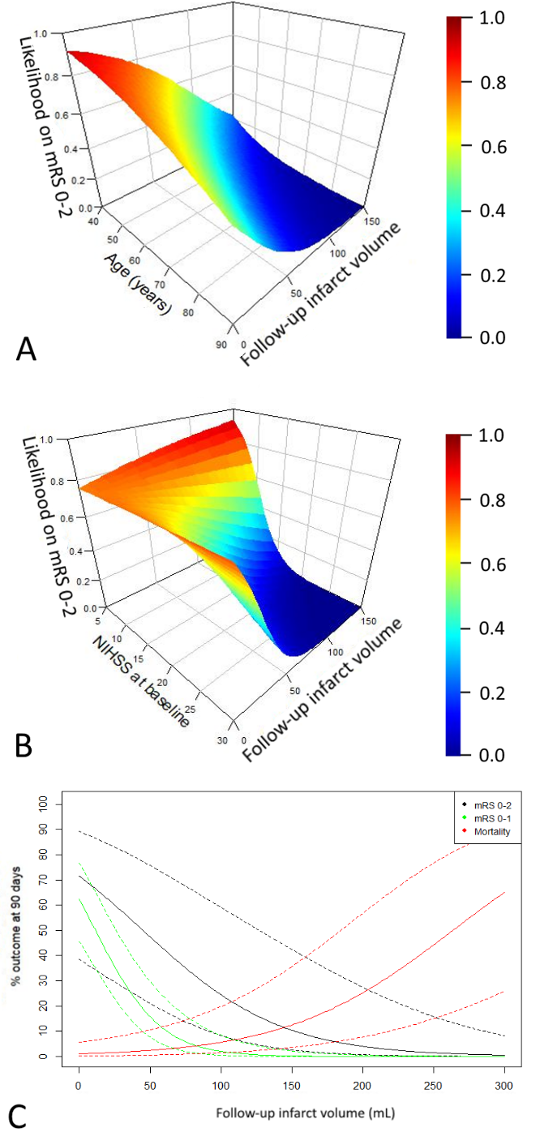

Online supplementary figure 2. Analysis of patients with FIV assessed on MR imaging only. A) Three-dimensional surface plots illustrating the relationship between follow-up infarct volume, adjusted probability of functional independence at 90 days (mRS 0-2) and age and B) baseline National Institutes of Health Stroke Scale (NIHSS) score. C) Estimated probability for excellent outcome (mRS 0-1), favorable outcome (mRS 0-2), and death (mRS of 6), adjusted for age and baseline NIHSS. Point estimates and 95% confidence interval.

Online supplementary figure 3a. Receiver operating characteristic (ROC) curves of follow-up infarct volume and dichotomized outcomes. Area under the receiver operating characteristic curves (AUC) were as follows: AUC of excellent outcome (mRS 0-1) = 0.80, functional independence (mRS 0-2) = 0.80, and death (mRS 6) = 0.79.
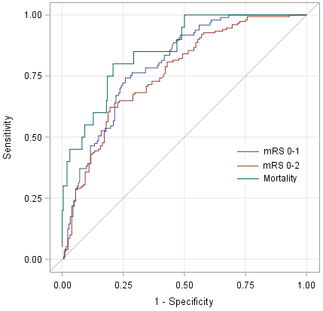
Online supplementary figure 3b. Receiver operating characteristic (ROC) curves of follow-up infarct volume and dichotomized outcomes for MR imaging only. Area under the receiver operating characteristic curves (AUC) were as follows: AUC of excellent outcome (mRS 0-1) = 0.80, functional independence (mRS 0-2) = 0.76, and death (mRS 6) = 0.86.

