**Supplementary Material**

**Thrombectomy for Acute Ischemic Stroke in the Elderly – A ‘Real World’ Experience**

**Supplementary Figure 1**

**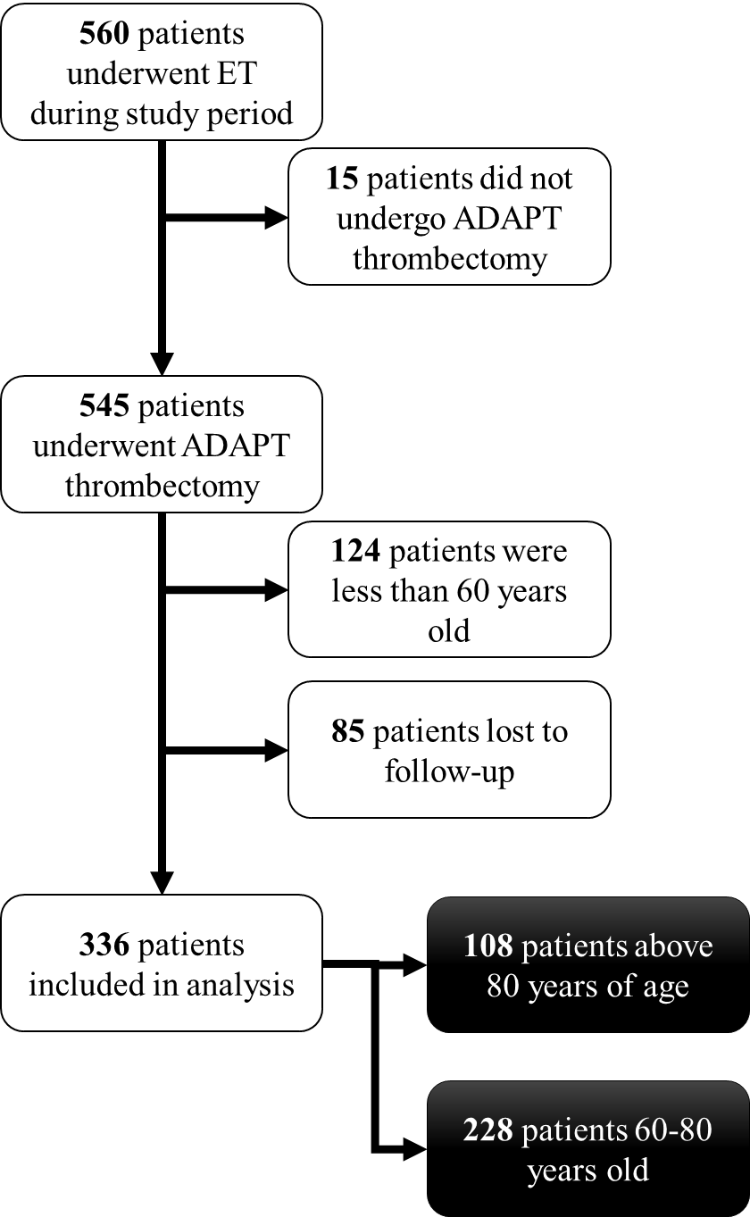**

**Supplementary Figure 1. Patient selection flow chart.**

**Supplementary Figure 2**

****

**Supplementary Figure 2. Age-dependent change in 90-day rates of good and bad outcomes after ET.** Good outcomes defined as mRS 0–2. Bad outcomes defined as mRS 3–6. Graph demonstrates an inflection point around 80 years of age demonstrating increased risk of poor outcomes.

**Supplementary Figure 3**

**C:\Users\Ali\Box Sync\Progress Work\2017.AgeGroupADAPT\Version5_1_15_17\Figures\FigureS3.tif**

**Supplementary Figure 3. Comparison of the 90-day mRS scores of elderly patients in the medical arm in this data compared to published retrospective datasets and to the meta-analysis of major RCTs.** \*ISTR-VISTA: SITS International Stroke Thrombolysis Registry and Virtual International Stroke Trials Archive (ref: 19). \*\*from Goyal et al (ref: 14).

**Supplementary Figure 4.**

**C:\Users\Ali\Box Sync\Progress Work\2017.AgeGroupADAPT\Version5_1_15_17\Figures\FigureS4.tif**

**Supplementary Figure 4. Comparison of the 90-day mRS scores of young patients (<80 years old) who underwent ET in this study compared to major trials.** Data from major trials was obtained from recent meta-analysis by Goyal et al (ref: 14).