ONLINE SUPPLEMENTUM
Testing Bioresorbable Stent Feasibility in a Rat Aneurysm Model

Supplementary Methods
Histology
Paraffin-embedded aneurysms were cut in the axis along the underlying parent artery in slices of 2 μm and stained. Stained slices were digitalized (omnyx VL120, GE, USA) and evaluated with the JVS viewer (JVS view 1.2 full version, http:// jvsmicroscope.uta.fi/software/, University of Tampere, Finland). Histologic scoring was performed blinded to treatment allocation and a previously used 4-scale grading system¹ was applied to characterize histology.
Tissue preparation for molecular analysis:
Shock frozen tissue samples were homogenized by roughly grinding the frozen tissue in a glass homogenizer. 100 μl of PBS containing 1% Triton X-100 and a cocktail of protease inhibitors (Complete™, EDTA-free protease inhibitor cocktail, Roche Diagnostics GmbH, Mannheim, Germany) were added and tissue further homogenized on ice. The crude homogenate was centrifuged for 10 min at 4°C, 13’000 rpm in a Biofuge Fresco centrifuge (Heraeus, Hanau, Germany). The supernatant was harvested and stored at -80°C until further analyses. Protein concentration was determined using the BCA method, according to manufacturer instructions (Pierce™ BCA protein assay kit, Thermoscientific, Rockford, IL, USA).
Gelatine zymography:
Gelatine SDS-PAGE zymography was performed to detect the enzymatic activity of MMP-2 and MMP-9. Five micrograms of protein homogenates were submitted to electrophoresis under non-reducing conditions in polyacrylamide gels containing type A gelatine from porcine skin (1% v/v). SDS was removed from the gels and catalytic sites activated by overnight incubation at 37°C in zymography buffer (10 mM CaCl2, 50 mM Tris, 50 mM NaCl, pH 7.65). Gels were stained with 0.1% Coomassie blue R250, 30% Methanol and 10% acetic acid. Gelatinolytic activity was determined by densitometric quantitation of the substrate lysis zones around 92 (pro-MMP-9) and 72 (pro-MMP-2) kDa using an image analysis software (ImageJ, U. S. National Institutes of Health, Bethesda, Maryland, USA, http://rsb.info.nih.gov/ij/.) Protein standards purified from human neutrophil MMP-9 and recombinant MMP-2 were used for normalization of the gels and quantification of MMP-9 and -2 as a function of the lysis zone.
Luminex analysis:
The assessment of cytokines/chemokines or other analytes was performed using a rat magnetic Luminex assay 7-plex kit (RnD Systems, Minneapolis, MN, USA), according to the manufacturer instructions. Concentration of the different analytes were determined in 100 µg of crude protein homogenates using Bio-Plex Manager Software 4.1.1 (Bio-Rad Laboratories) with a 5-parameter logistic curve-fitting method.
Micro-Computer Tomogram (μ-CT):
Micro-CT scans were performed with a desktop cone-beam scanner μCT 40 (Scanco Medical AG, Brüttisellen, Switzerland) with the following parameters: The X-ray source (E) was set at 70 kVp, with 114 μA at high resolution (1000 projections/180°), which showed an image matrix of 2048 x 2048 pixels; the diameter of the sample holder was 16.4 mm, which allowed an increment (resolution) of 8 μm (= voxel size); Integration time was set on 300 ms. The sample had a total number of approx. 900 slices (7.2 mm in length), with a measurement time of 105 min.
Optical coherence tomography (OCT):
For OCT analysis, a fiber based swept source optical coherence tomography (SSOCT) system with a centre wavelength of 1315nm and a telecentric scanner setup were used. The laser source (Santec HSL-20-50-M, A-scan rate 50kHz, Santec, Ohkusa-Nenjozaka, Komaki, Japan) provides a center wavelength of 1315nm and a coherence length of 21mm. The system provides a lateral resolution of 50m and an axial resolution of 10μm in air or 7μm in tissue respectively, assuming a refractive index of 1.38. To perform C-scans, we used a telecentric scanning system, consisting of two galvo mirrors and a scanning lens package, providing a lateral resolution of 50μm. The laser polarization state for signal optimization was adjusted with two fiber polarization controllers (FPC020, Thorlabs, Newton, NJ, USA). The field of view was set to 5mm times 5mm with a lateral step size of 10μm in x- and y-direction. The axial sampling rate was set to 4096 pixels per A-scan. Each aneurysm was measured at least four times in direct succession and in the same position. The acquired C-scans of each sample were averaged to increase the signal-to-noise ratio. For assessment of neointima thickness, we measured the distance between the luminal stent surface and the outermost tissue layers of the aorta (adventitia) by optical coherence tomography (OCT) (Supplementum figure IV).

Supplemental Figures and Figure Legends
Supplementary Figure 1: Details of histologic evaluation comparing animals with no treatment, with brMAS treatment, with aspirin treatment, and with brMAS + aspirin treatment.
Values are presented as median and interquartile range and arbitrary units 0-3 on the y-axis represent categories (“none”, “mild”, “moderate”, “severe”) according to the previously described neointima score.¹ For neoinitma thickness values are given in μm as an average of three measurements of the neointima along the former orifice and shown as mean ± SD. ANOVA-testing between categories revealed p-values as shown in the titles. Asterisks between subcategories indicate statistically significant differences between these groups in direct testing (Mann-Whitney-U-Test for non-parametrically distributed values; student t-test for neointima thickness).
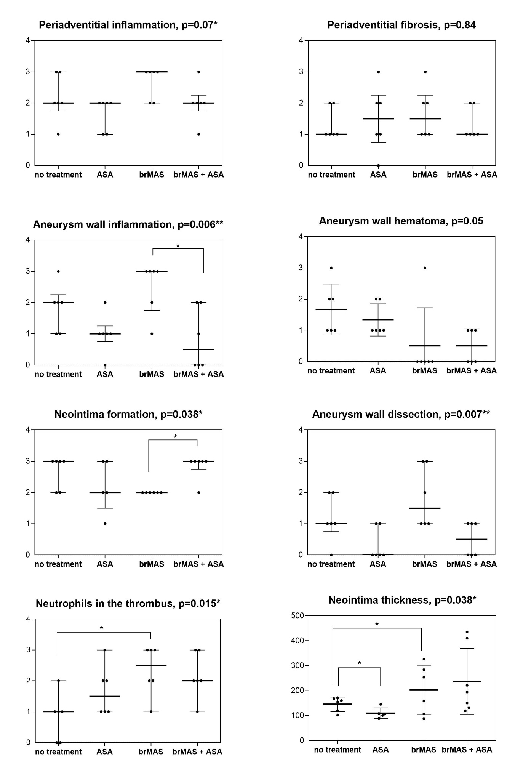
Supplementary Figure II: Details of histologic evaluation comparing bioresorbable magnesium-alloy stents (brMAS) with permanent cobalt-chromium stents (CoCrS)
Values are presented as median and interquartile range and arbitrary units 0-3 on the y-axis represent categories (“none”, “mild”, “moderate”, “severe”) according to the neointima score.¹ For neoinitma thickness values are given in μm as an average of three measurements of the neointima along the former orifice and shown as mean ± SD. For statistical testing p-values are given in the title.

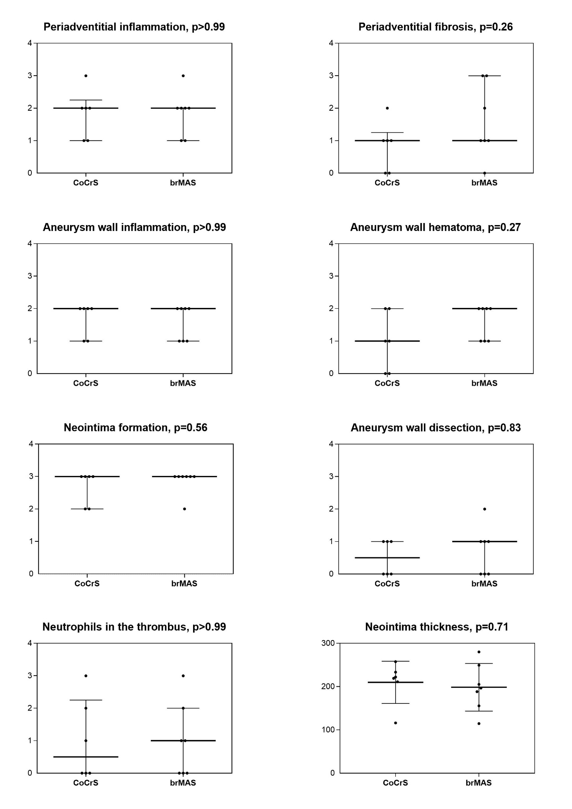
Supplementary Figure III: OCT analysis of the degrading stent
A: Side and frontal view on a 3D volume reconstruction of a stent after 6 months implantation; B: Maximal projection from above; C: corresponding B-scan (the doted red line in B indicates the cutting plane); a) cutting surface; b) transition from lumen to endothelium; c) stent loop; d) aneurysm dome; e) resorbed stent loop; f) still existing stent loop; g) shadow below stent loop (since the laser cannot penetrate the magnesium part of the stent); h) slight shadow (indicating the laser light penetrated the degraded stent material.

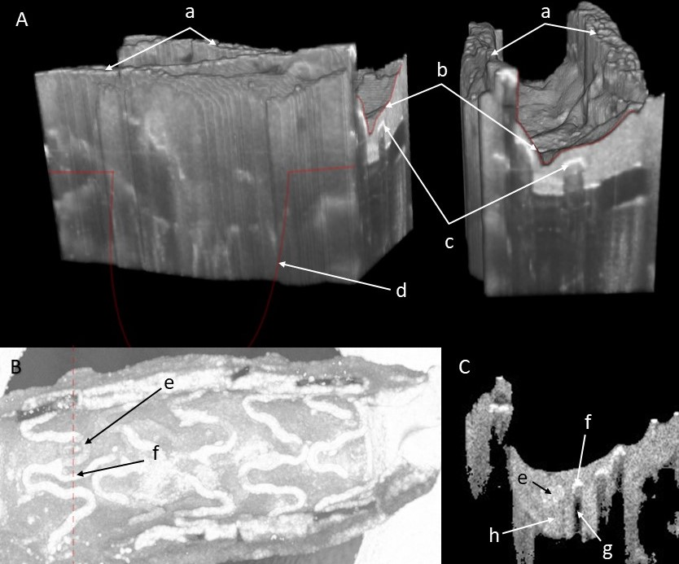

Supplementary Table
Supplementary Table 1: Molecular markers (means ±SD) in pg/ml homogenate for cytokines and extrapolated from semi-quantitative analysis in pg/ml for MMPs by treatment categories. Aspirin administration effectively controlled the pronounced inflammation in stent-treated animals.
Molecular marker | No Stent | brMAS | brMAS + Aspirin | ANOVA (p-value)
Cytokine/Chemokine Level in Subacute State (1 week)
Il1β | 4712 ± 2823 | 3200 ± 2100 | 243.7 ± 127.4 | 0.01*
Il6 | 520.4 ± 210.7 | 957.1 ± 637.9 | 286.9 ± 27.7 | 0.04*
VEGF | 580.7 ± 291.1 | 350.6 ± 237.3 | 357.5 ± 236.4 | 0.24
MMP-9 | 33.06 ± 17.8 | 31.29 ± 6.1 | 15.82 ± 10.2 | 0.054
MMP-2 | 3.83 ± 1.2 | 8.83 ± 3.3 | 4.16 ± 1.8 | 0.002**
Cytokine/Chemokine Level in Chronic State (4 weeks)
Il1β | 1363 ± 1408 | 3461 ± 2986 | 1551 ± 1056 | 0.17
Il6 | 652 ±233.2 | 431.4 ±116.8 | 652 ± 233.2 | 0.03*
VEGF | 795.7 ± 1120 | 525.6 ± 417.4 | 899 ± 789.6 | 0.76
MMP-9 | 5.56 ± 4.0 | 14.21 ± 10.6 | 12.74 ± 5.1 | 0.17
MMP-2 | 10.31 ± 4.7 | 9.46 ± 4.7 | 15.73 ± 3.3 | 0.047*

Reference
1. Marbacher S, Marjamaa J, Bradacova K, et al. Loss of mural cells leads to wall degeneration, aneurysm growth, and eventual rupture in a rat aneurysm model. Stroke 2014;45:248-54.

