**SUPPLEMENTAL MATERIAL**

**TITLE:** Current Evidence of Anesthesia Management during Endovascular Stroke Therapy: Updated Systematic Review and Meta-Analysis

**Supplemental Methods**

Complete Search algorithm used in MEDLINE search

((“stroke”, “endovascular”, “conscious sedation”, “monitored anesthesia”, “transcatheter”, “thrombolysis”, [“acute stroke” AND “anesthesia”], “general anesthesia”, “intracranial embolism”, “thrombosis”, “fibrinolytic agents”, “thromboembolism”, “cohort”, “case control”, “case report”, “fibrinolysis”, “recanalization”, “embolectomy”, “thrombectomy”, “endovascular treatment”, “stent retriever”, “reperfusion”, [“anesthesia” AND “hemodynamic instability”], “ventilator associated complication”, “randomized controlled trials”, “case series”, “mechanical thrombectomy”)). References provided in various articles were also reviewed to find any relevant study which compared efficacy and safety of anesthesia during endovascular stroke treatment.

**Supplemental Tables**

**Supplemental Table I:** Excluded studies with reasons for exclusion

|  |  |
| --- | --- |
| Trial name | Reason for exclusion |
| Langner S et al1 | Language other than English |
| Nii et al2 | Not compared with general anesthesia |
| Simonsen et al3 | No comparison of local vs general anesthesia |
| Bouslama et al4 | No comparison of local vs general anesthesia |
| Kansagra et al5 | Survey about workflow practices including type of anesthesia being used for thrombectomy |
| Romero et al6 | Survey about workflow practices including type of anesthesia being used for thrombectomy |
| Athiraman et al7 | No comparison group |
| Rasmussen et al8 | Survey about workflow practices including type of anesthesia being used for thrombectomy |
| Wang et al9 | No comparison of local vs general anesthesia |
| Badenes et al10 | Outcome measures are different |
| Sivasankar et al11 | No comparison of local vs general anesthesia |
| Burnsed et al12 | Discussion about general anesthesia |
| Rangel-Castilla et al13 | No comparison of local vs general anesthesia |
| Hametner et al14 | Outcome measures are different |
| Emiru et al15 | Survey about workflow practices including type of anesthesia being used for thrombectomy |
| Leishangthem et al16 | Case report |
| Menon et al17 | Survey about workflow practices including type of anesthesia being used for thrombectomy |
| Isozaki et al18 | Case report |
| Yun et al19 | Case report |
| Ullah et al20 | Case report |
| Nishia et al21 | Case report |

**Supplemental Table II:** Baseline characteristics of the included patients

|  |  |  |  |  |  |  |
| --- | --- | --- | --- | --- | --- | --- |
| **Author or trial, Year of publication** | **Baseline NIHSS score of GA/non- GA patients** | **Mean Age of GA/ Non-GA Patients** | **No. of HTN GA/ Non-GA Patients** | **No. of Smoking GA/ Non-GA Patients** | **No. of CAD GA/ Non-GA Patients** | **%Female GA/ %Non-GA** |
| ANSTROKE, 2017 | 20 (15.5–23)/17 (14–20.5) ** | 73/72 | 27/22 | 4/8 | 9/5 | 58/51.0 |
| Abou-Chebl, 2014 | 18 (7–40)/ 16 (7–29)** | 66/69 | 148/74 | 59/28 | 56/29 | 48.5/48.2 |
| Abou-Chebl, 2015 | 18 (13-21)/ 17 (15-21)** | 69/69 | 108/196 | NA | NA | 49.0/49.4 |
| GOLIATH, 2018 | 18 (15–21)/ 17 (14–20)** | 71/71.8 | 39/32 | 20/20 | NA | 44.6/52.4 |
| Gratz, 2014 | 17.47±9.31/15.20±7.32* | 68.2±14.7 (combined) | NA | NA | NA | NA |
| HERMES, 2018 | 16 (8.5)/ 18 (7.5)** | 65/67 | NA | NA | NA | 45.1/48.5 |
| Jadhav, 2017 | - | 67/69 | 39/43 | 18/18 | NA | 59/45.9 |
| Jagani, 2016 | 21 (16-25)/ 17 (12-21) ** | 63/68 | 29/46 | 20/26 | 8/19 | 45.0/49.0 |
| Janssen, 2016 | 17 (13-20)/ 17 (14-20)**  16.8 (3.9)/ 17.2 (3.7)* | 68/73 | 38/26 | 13/8 | NA | 53.0/58.0 |
| Just, 2016 | 20 (17–23)/ 17 (13–23)** | 60/63 | 24/37 | 25/27 | NA | 40.0/37.0 |
| McDonald, 2015 | 18.9±6.9/16.4±5.8* | 71/70 | NA | NA | NA | 52/56 |
| Mundiyanapurath, 2015 | 18 (7–40)/ 16 (7–29)** | 73/67 | NA | NA | NA | 55.0/60.0 |
| SIESTA, 2016 | - | 72/71 | 53/54 | 9/13 | NA | 34.2/45.5 |
| Slezak, 2017 | 18 (15–21)/ 17 (14–20)** | 70.9/70.5 | 146/66 | 111/49 | 65/21 | 47.4/56.3 |
| van den Berg, 2015 | 16 (8.5)/ 18 (7.5)** | 57/62 | 37/130 | NA | 16/43 | 50.0/56.4 |
| Whalin, 2014 | 15 (4)/ 14 (6)** | 63.5/68.2 | 100/57 | NA | NA | 49/51 |

* mean (SD); ** median (IQR)

**Supplemental Table III:** Risk of bias assessment of post-hoc analyses of randomized-controlled clinical trials (RCTs) comparing endovascular therapy to standard therapy and RCTs comparing GA to non-GA.

|  |  |  |  |  |  |  |
| --- | --- | --- | --- | --- | --- | --- |
| **Study** | **Random sequence generation (selection bias)** | **Allocation concealment (selection bias)** | **Blinding of participants and personnel (performance bias)** | **Incomplete outcome data (attrition bias)** | **Selective reporting (reporting bias)** | **Other potential bias** |
| ANSTROKE, 2017 | Low risk  Quote: random allocation in blocks to either GA or CS in a 1:1 ratio using sealed nontransparent envelopes | Low risk Quote: random allocation using sealed nontransparent envelopes | High risk comment: doctors knew about the type of anesthesia being used. Blinded end point evaluation | Low risk comment: no patient lost to follow up | Low risk comment: all outcomes appear to be reported | Low risk comment: no other apparent bias |
| GOLIATH, 2018 | Low risk  Quote: random allocation in blocks to either GA or CS, randomization was achieved by a web-based program | Low risk Quote: randomization was achieved by a web-based program, block randomization (with sizes 4, 6, and 8) was performed after stratification | High risk comment: doctors knew about the type of anesthesia being used. Blinded end point evaluation | Low risk comment: no patient lost to follow up | Low risk comment: all outcomes appear to be reported | Low risk comment: no other apparent bias |
| SIESTA, 2016 | Low risk  Quote: randomized 1:1 (using sealed, opaque envelopes based on a computer-generated list not allowing for sequence guessing) | Low risk Quote: random allocation using sealed nontransparent envelopes | High risk comment: Doctors knew about the type of anesthesia being used. Blinded end point evaluation | Low risk comment: No patient lost to follow up | Low risk Comment: all outcomes appear to be reported | Low risk Comment: all outcomes appear to be reported |

**Supplemental Table IV:** Quality assessment of included studies with the Newcastle–Ottawa Scale

|  |  |  |  |  |
| --- | --- | --- | --- | --- |
| **Study name** | **Selection** | **Comparability** | **Outcome** | **Overall score** |
| Abou-Chebl, 2014 | *** | ** | *** | 8/9 |
| Abou-Chebl, 2015 | **** | ** | *** | 9/9 |
| Gratz, 2014 | **** | ** | *** | 9/9 |
| HERMES, 2018 | **** | ** | *** | 9/9 |
| Jadhav, 2017 | *** | ** | *** | 8/9 |
| Jagani, 2016 | *** | ** | *** | 8/9 |
| Janssen, 2016 | *** | ** | *** | 8/9 |
| Just, 2016 | *** | ** | ** | 7/9 |
| McDonald, 2015 | *** | ** | *** | 8/9 |
| Mundiyanapurath, 2015 | **** | ** | *** | 9/9 |
| Slezak, 2017 | **** | ** | *** | 9/9 |
| van den Berg, 2015 | *** | ** | *** | 8/9 |
| Whalin, 2014 | *** | ** | *** | 8/9 |
| Overall score | 44/52 | 26/26 | 38/39 | 108/117 |

**Supplemental Table V:** Comparison of mean procedural time in patients treated with GA and non-GA

|  |  |  |
| --- | --- | --- |
| **First author or trial name, year** | **Procedure time using GA, min** | **Procedure time using non-GA, min** |
| ANSTROKE, 2017 | 55 | 74 |
| Abou-Chebl, 2014 | 100.6 | 105.7 |
| GOLIATH, 2018 | 37.5 | 30 |
| Jadhav, 2017 | 86.5 | 99 |
| Jagani, 2016 | 87 | 82 |
| Janssen, 2016 | 51 | 45 |
| Mundiyanapurath, 2015 | 105 (median) | 100 (median) |
| SIESTA, 2016 | 111.6 +/- 62.5 | 129.9 +/- 62.5 |
| Whalin, 2014 | 76.1 | 84.7 |

**Supplemental Figures**

**Supplemental Figure I:** Flow-Chart Diagram Presenting the Selection of Eligible Studies

Identification

Records identified through EMBASE/MEDLINE (N=356)

Records identified through PubMed (N=1765)

Records after duplicates removed (N=2121)

Screening

Records excluded

(N=2075)

Records screened

(N=2121)

Eligibility

Full text articles excluded,

Stroke outcomes not provided or unavailable (N=2), no comparison group (N=8), survey (N=5), case report (N=5), language other than English (N=1), studies prior to 2015 and did not use stentrievers (N=9)

Full-text articles assessed for eligibility (n=46)

Included

Studies included in qualitative synthesis (N=16)

Studies included in quantitative synthesis (meta-analysis)

(N=16)

**Supplemental Figure II:** Funnel plot of the randomized and non-randomized studies for the outcome of functional independence

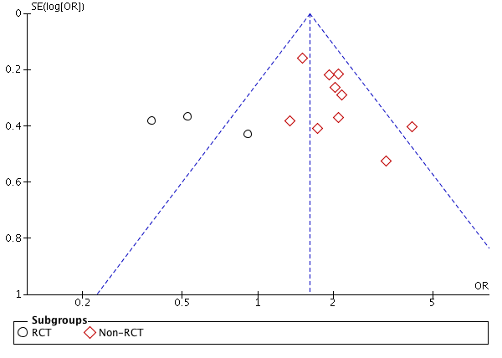

**Supplemental Figure III:** Funnel plot of the randomized and non-randomized studies for the outcome of mortality

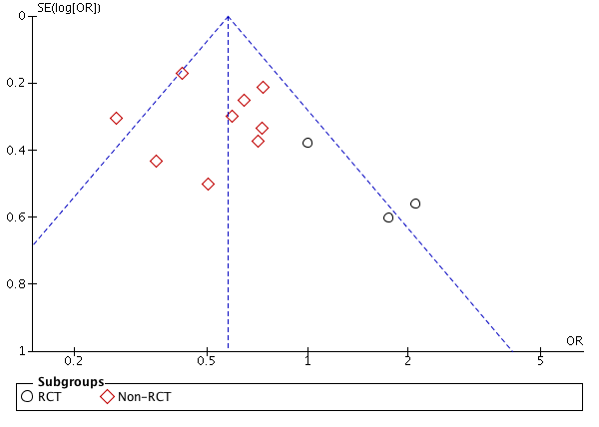

**Supplemental Figure IV:** Pooled odds ratios of 3-month functional independence for patients in non-GA and GA groups

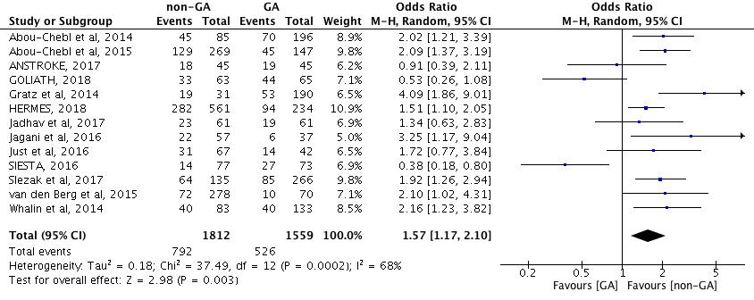

**Supplemental Figure V:** Pooled odds ratios of 3-month mortality for patients in non-GA and GA groups

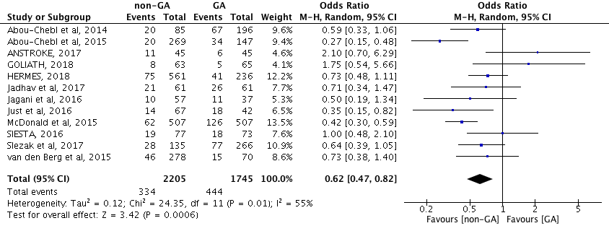

**Supplemental Figure VI:** Pooled odds ratios of any intracranial hemorrhage for patients in non-GA and GA groups

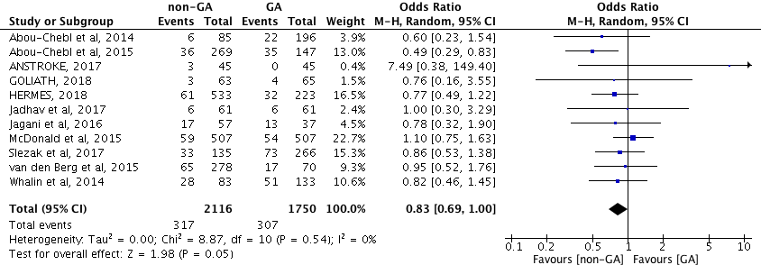

**Supplemental Figure VII:** Pooled odds ratios of symptomatic intracranial hemorrhage for patients in non-GA and GA groups

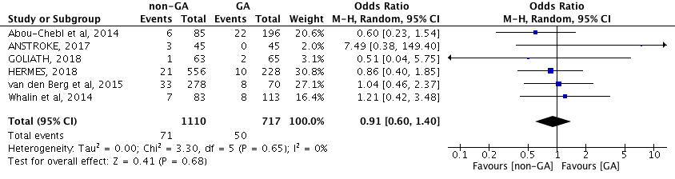

**Supplemental Figure VIII:** Pooled odds ratios of successful reperfusion (mTICI 2b/3) for patients in non-GA and GA groups

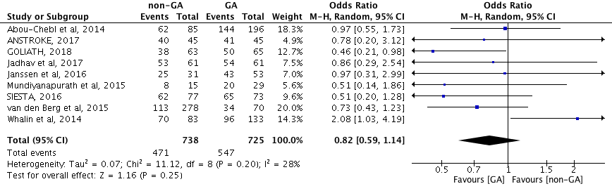

**Supplemental Figure IX:** Pooled odds ratios of hemodynamic instability for patients in non-GA and GA groups

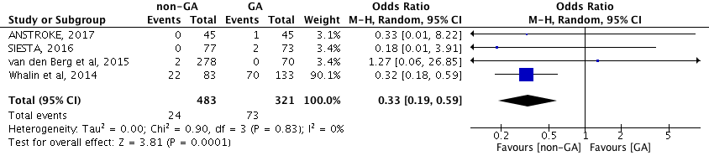

**Supplemental Figure X:** Pooled odds ratios of bodily movements for patients in non-GA and GA groups

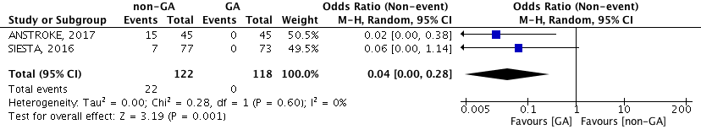

**Supplemental Figure XI:** Pooled odds ratios of respiratory complications for patients in non-GA and GA groups

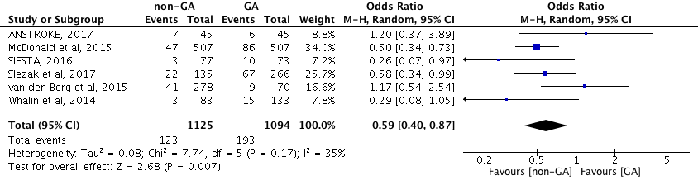

**Supplemental Figure XII:** Pooled odds ratios of procedure-related complications for patients in non-GA and GA groups

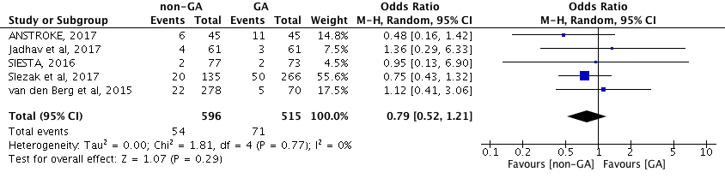

**Supplemental Figure XIII:** Pooled odds ratios of posterior circulation occlusion selected either for non-GA and GA groups

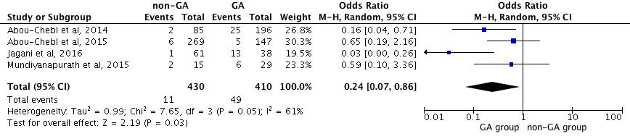

**Supplemental Figure XIV:** Pooled odds ratios of 3-month functional independence in patients with anterior circulation occlusion selected either for non-GA and GA groups

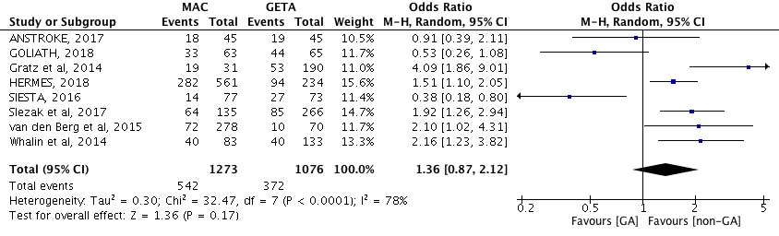

**Supplemental Figure XV:** Pooled odds ratios of 3-month mortality in patients with anterior circulation occlusion selected either for non-GA and GA groups

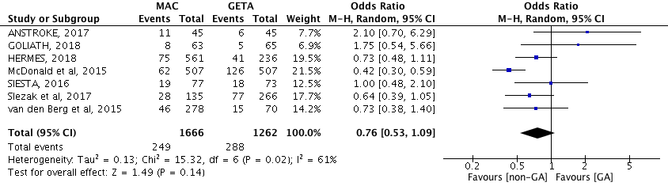

**Supplemental Figure XVI:** Subgroup analysis after adjustment of potential confounders comparing the odds of functional independence for non-GA and GA groups

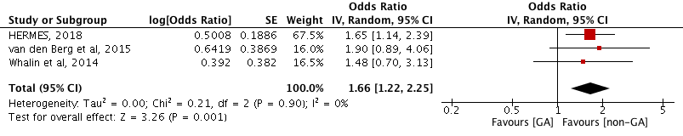

**Supplemental Figure XVII:** Subgroup analysis after adjustment of potential confounders comparing the odds of mortality for non-GA and GA groups

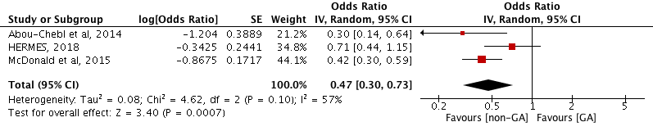

**Supplemental Figure XVIII:** Meta-regression in which the dependent outcome is the effect size (log of the OR of the three-month mortality), and the explanatory variables (independent variables) are baseline stroke severity quantified by the baseline average NIHSS-score and the type of anesthesia (GA versus non-GA).

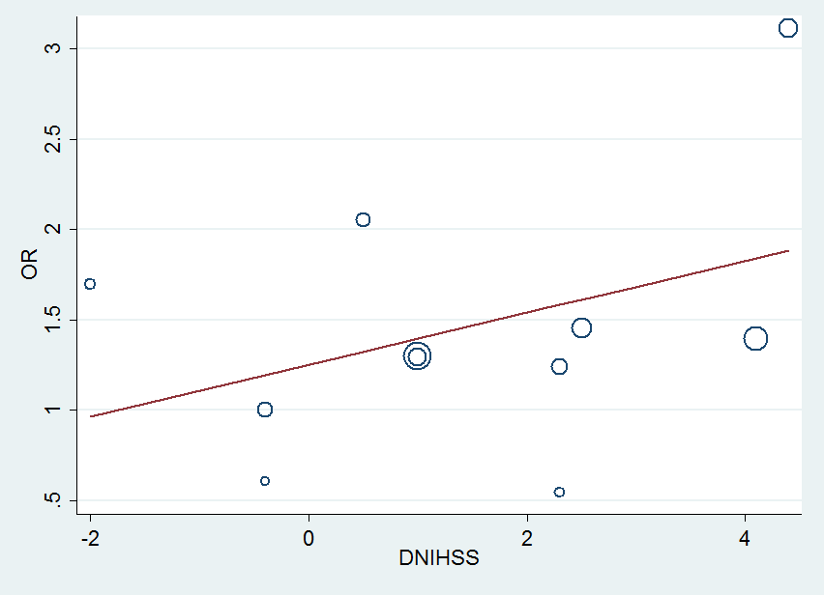

**Supplemental Figure XIX:** Meta-regression in which the dependent outcome is the effect size (log of the OR of the three-month Functional Independence), and the explanatory variables (independent variables) are baseline stroke severity quantified by the baseline average NIHSS-score and the type of anesthesia (GA versus non-GA).



**: Supplemental References**

1. Langner S, Khaw AV, Fretwurst T, et al. [Endovascular treatment of acute ischemic stroke under conscious sedation compared to general anesthesia - safety, feasibility and clinical and radiological outcome]. RoFo : Fortschritte auf dem Gebiete der Rontgenstrahlen und der Nuklearmedizin 2013;185(4):320-7. doi: 10.1055/s-0032-1330361 [published Online First: 2013/02/20]
2. Nii K, Hanada H, Hiraoka F, et al. Usefulness of Consciousness Sedation with Dexmedetomidine and Pentazocine during Endovascular Treatment for Acute Stroke. Neurol Med Chir (Tokyo). 2017 Dec 19.
3. Simonsen CZ, Mikkelsen IK, Karabegovic S, et al. Predictors of Infarct Growth in Patients with Large Vessel Occlusion Treated with Endovascular Therapy. Front Neurol. 2017 Oct 30;8:574. doi: 10.3389/fneur.2017.00574. eCollection 2017.
4. Bouslama M, Haussen DC, Aghaebrahim A, et al. Predictors of Good Outcome After Endovascular Therapy for Vertebrobasilar Occlusion Stroke. Stroke. 2017 Dec;48(12):3252-3257.
5. Kansagra AP, Meyers GC, Kruzich MS, et al. Wide Variability in Prethrombectomy Workflow Practices in the United States: A Multicenter Survey. AJNR Am J Neuroradiol. 2017 Dec;38(12):2238-2242.
6. Romero Kräuchi O, Valencia L, Iturri F, et al. National survey on perioperative anaesthetic management in the endovascular treatment of acute ischaemic stroke. Rev Esp Anestesiol Reanim. 2018 Jan;65(1):13-23.
7. Athiraman U, Sultan-Qurraie A, Nair B, et al. Endovascular Treatment of Acute Ischemic Stroke Under General Anesthesia: Predictors of Good Outcome. J Neurosurg Anesthesiol. 2017 Jul 31.
8. Rasmussen M, Simonsen CZ, Sørensen LH, et al. Anaesthesia practices for endovascular therapy of acute ischaemic stroke: a Nordic survey. Acta Anaesthesiol Scand. 2017 Sep;61(8):885-894.
9. Wang A, Stellfox M, Moy F, et al. General Anesthesia During Endovascular Stroke Therapy Does Not Negatively Impact Outcome. World Neurosurg. 2017 Mar;99:638-643.
10. Badenes R, García-Pérez ML, Bilotta F. Intraoperative monitoring of cerebral oximetry and depth of anaesthesia during neuroanesthesia procedures. Curr Opin Anaesthesiol. 2016 Oct;29(5):576-81.
11. Sivasankar C, Stiefel M, Miano TA, et al. Anesthetic variation and potential impact of anesthetics used during endovascular management of acute ischemic stroke. J Neurointerv Surg. 2016 Nov;8(11):1101-1106.
12. Burnsed BC, Arthur AS. Use of General Anesthesia for Emergent Large Vessel Occlusion Patients.World Neurosurg. 2015 Dec;84(6):1498-500.
13. Rangel-Castilla L, Cress MC, Munich SA, et al. Feasibility, Safety, and Periprocedural Complications of Pipeline Embolization for Intracranial Aneurysm Treatment Under Conscious Sedation: University at Buffalo Neurosurgery Experience. Neurosurgery. 2015 Sep;11 Suppl 3:426-30.
14. Hametner C, Stanarcevic P, Stampfl S, et al. Noninvasive cerebral oximetry during endovascular therapy for acute ischemic stroke: an observational study. J Cereb Blood Flow Metab. 2015 Nov;35(11):1722-8.
15. Emiru T, Chaudhry SA, Qureshi AI. A survey of preprocedural intubation practices for endovascular treatment of acute ischemic stroke. J Vasc Interv Neurol. 2014 Sep;7(3):30-3.
16. Leishangthem L, Satti SR. Vessel perforation during withdrawal of Trevo ProVue stent retriever during mechanical thrombectomy for acute ischemic stroke. J Neurosurg. 2014 Oct;121(4):995-8.
17. Menon BK, Almekhlafi MA, Pereira VM, et al. Optimal workflow and process-based performance measures for endovascular therapy in acute ischemic stroke: analysis of the Solitaire FR thrombectomy for acute revascularization study. Stroke. 2014 Jul;45(7):2024-9
18. Superselective Provocative Test with Propofol Using Motor-Evoked Potential Monitoring for Managing Cerebral Arteriovenous Malformations Fed by the Anterior Choroidal Artery. J Stroke Cerebrovasc Dis. 2016 Sep;25(9):e153-7.
19. Yun JW, Ahn SW, Kim YH et al. Intraarterial mechanical thrombectomy for the treatment of postoperative cerebral infarction: a case report. Korean J Anesthesiol. 2014 May;66(5):402-6.
20. Ullah N, Khan AA, Suri MF et al. Intra-arterial etomidate for provocative testing in embolization procedure for cerebral arteriovenous malformation. J Neurosurg Anesthesiol. 2015 Jan;27(1):71-2.
21. Nishida A, Tokunaga K, Hishikawa T et al. Endovascular coil embolization of a ruptured distal anterior choroidal artery aneurysm associated with ipsilateral middle cerebral artery occlusion--case report. Neurol Med Chir (Tokyo). 2011;51(10):716-9.