SUPPLEMENTAL MATERIAL

SUPPLEMENTAL TABLES
Supplementary Table I: Distribution of RACE Alert Population per 12-month interval during the study period.
 | Any stroke or TIA | LVO on CTA | Mechanical Thrombectomy
July 2015 – June 2016 (n=168) | 122 (73%) | 54 (32%) | 37 (22%)
July 2016 – June 2017 (n=159) | 113 (71%) | 70 (44%) | 50 (31%)
July 2017 – June 2018 (n=165) | 120 (73%) | 58 (35%) | 38 (23%)
p-value* | 0.984 | 0.562 | 0.824
*Cochran-Armitage test
LVO: large vessel occlusion; TIA: transient ischemic attack; CTA: computed tomography angiography

SUPPLEMENTAL FIGURES
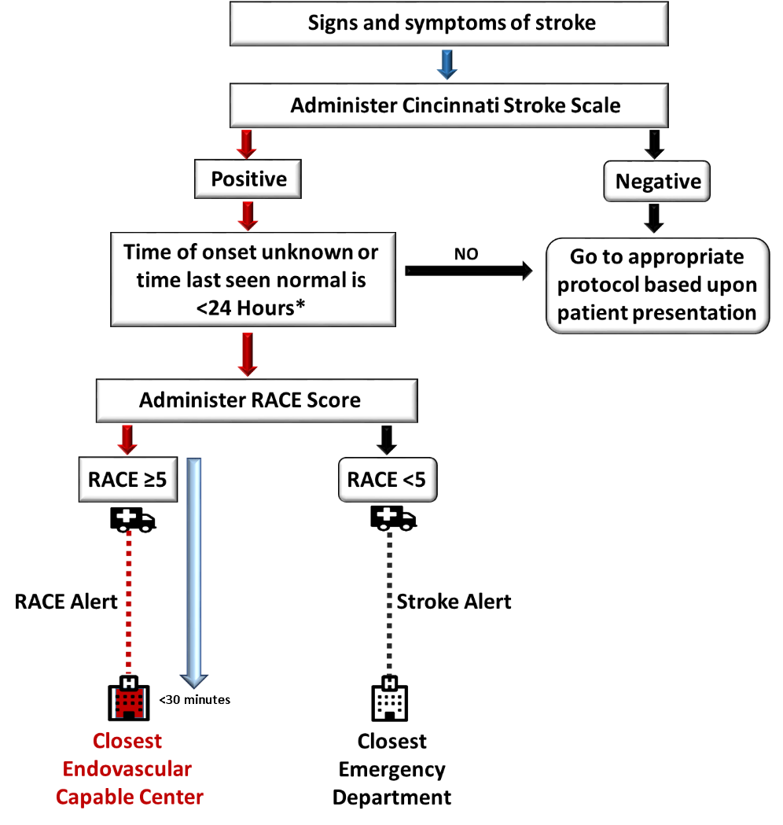
Supplemental Figure I. RACE Alert Protocol. *Protocol was modified in March 2018 from last seen normal <12hours to <24hours. RACE Scale administration to transport of patient to closest ECC should ideally be <30 minutes.

Supplemental Figure II. TRACER Protocol. ED: emergency department; CTA; computed tomography angiography

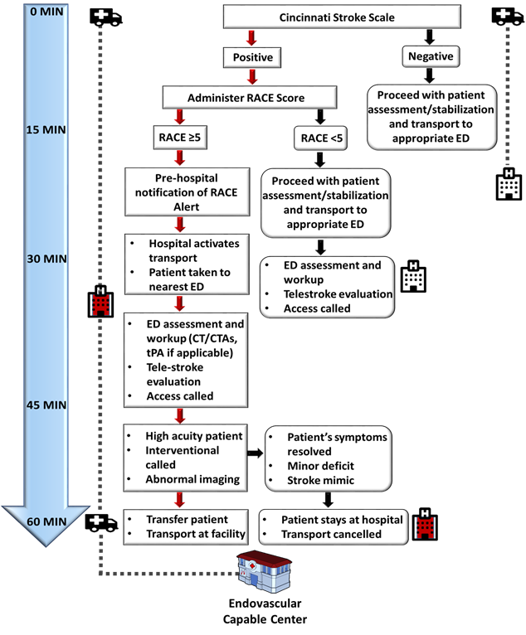

SUPPLEMENTAL METHODS
5-Hospital Network Details

Hospital Network PSCs
1st PSC:
Neuro ICU- No
Total Beds: 311
Accreditation: Joint Commission Primary Stroke Center

2nd PSC:
Neuro ICU- No
Total Beds: 72
Accreditation: Joint Commission Primary Stroke Center

3rd PSC:
Neuro ICU- No
Total Beds: 300
Accreditation: DNV GL Healthcare Primary Stroke Center

Hospital Network ECCs
1st ECC:
Neuro ICU- Yes
Total Beds: 794
Accreditation: Joint Commission Comprehensive Stroke Center

2nd ECC:
Neuro ICU- Yes
Total Beds: 267
Accreditation: Joint Commission Primary Stroke Center (with interventional capabilities)

RACE Alert Endovascular Capable Center Emergency Department Protocol:
