Illustrative case

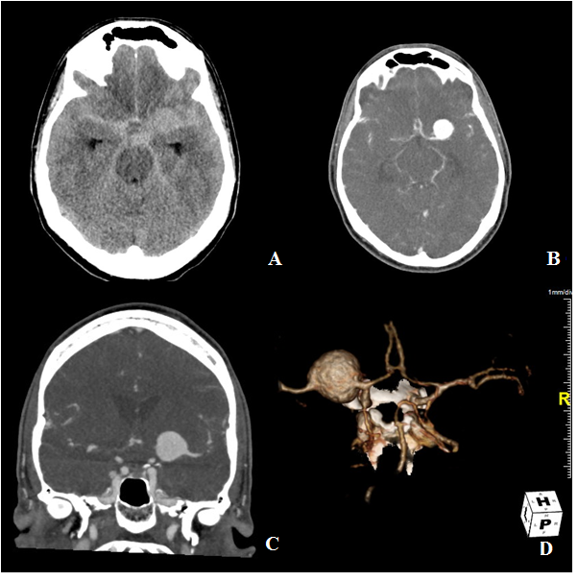
The following case concerns a patient with a ruptured left M1 aneurysm who presented with headache and vomiting but no neurological deficit. The patient’s Glasgow Coma Scale was E4M6V5, WFNS grade 1. The images below show CT (A)/ CTA (B-C) images and a 3D (D) reconstruction.

The aneurysm was treated with a flow diverter and was additionally coiled within the same procedure. The used technique was as following (E-H): Jailing of the microcatheter (E) followed by deployment of a Surpass 4x40mm flow diverter (high mesh density, over-the-wire FD) (F) and subsequent coiling of the aneurysm (G: after first coil; H: after last coil)
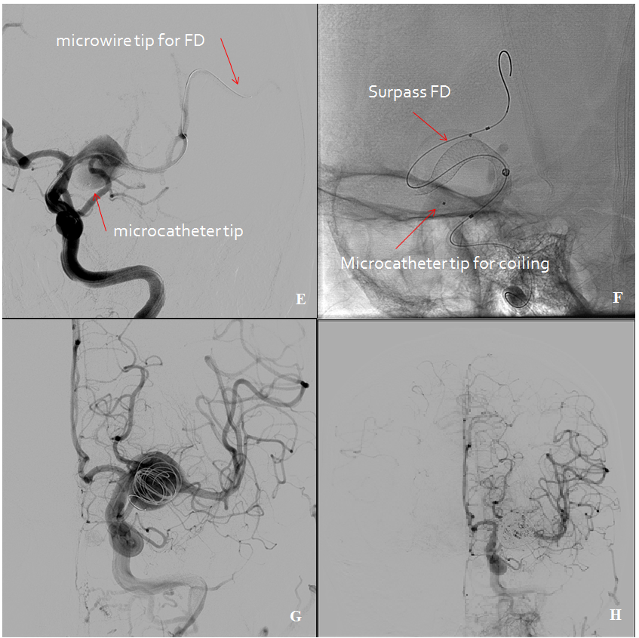

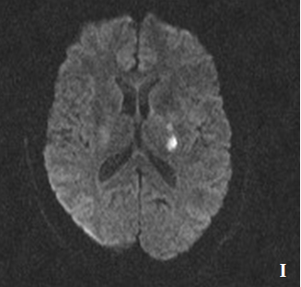
Two days after the procedure, the patient suddenly developed a mild right-sided hemiparesis and a mild aphasia. An MRI was performed, showing diffusion restriction in the left posterior limb of the internal capsule and corona radiata (I). A platelet function test (Verify Now) was performed 5 days after and showed 97% inhibition clopidogrel responder. The patient fully recovered within a year.

5 days after treatment, a control DSA was performed showing remodeling of the M1 segment and complete aneurysm occlusion (J-K).
