Simplified selection criteria for patients with longer or unknown time to treatment predict good outcome after mechanical thrombectomy

Simon Nagel MD* ¹, MD Christian Herweh MD* ², Johannes Pfaff ², Simon Schieber MD ¹, Silvia Schönenberger MD ¹, Markus A. Möhlenbruch MD ², Martin Bendszus MD ²,
Peter A. Ringleb ¹

¹ Department of Neurology, University Hospital Heidelberg, Germany
² Department of Neuroradiology, University Hospital Heidelberg, Germany
*these authors contributed equally

Suppl. material

Local Imaging algorithms and treatment recommendations

In general our local standard operation protocols (SOP) were following national and international guidelines for imaging and acute treatment of acute ischemic stroke patients. Due to participation in clinical trials (f.e. ECASS 4 and WAKE-UP) and other local research projects, we performed more magnetic resonance imaging (MRI) in patients and with longer or unknown time window. MRI included diffusion-weighted-imaging (DWI), MR-angiography (MRA) with Time-of-Flight (TOF) imaging and contrast-enhanced aortic arch MRA, fluid-attenuated-inversion-recovery (FLAIR) imaging and MR-perfusion (MRP) with a trend to perform less MR-imaging over the years. CT-perfusion (CTP) was recommended between 2014 and 2015 in all CT examined cases eligible for an acute recanalization therapy, but over the following years rather discouraged due to inconclusive findings in the early time windows. Importantly, treatment decisions were made by the physicians on call and patients could also be treated outside the current guidelines or SOP recommendations. Premorbid clinical disability was not necessarily on exclusion criterion for MT.
An overview over our local SOPs for acute recanalization therapies in the anterior circulation between 2014 and 2017 is given in the following diagrams.

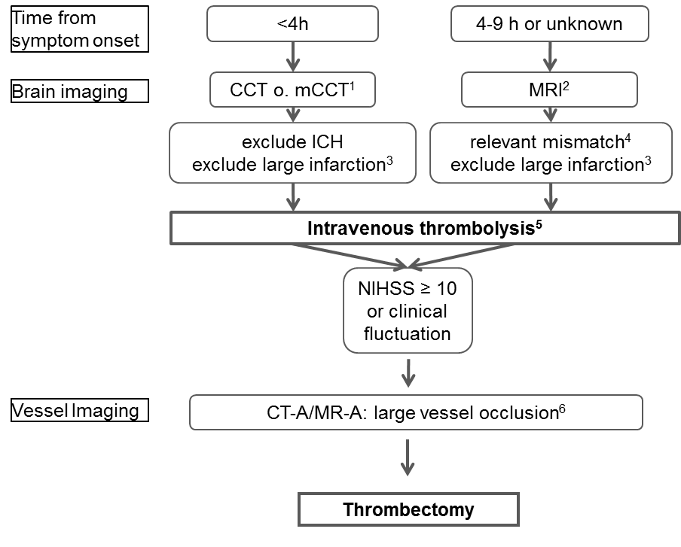

Figure S1: Local SOP in 2014 valid until July 2015)
CCT = cranial computed tomography, mCCT = multimodal CCT including aortic arch CT-angiography and CT Perfusion, MRI = magnetic resonance imaging, ICH = intracranial hemorrhage
¹ perform if large vessel occlusion is suspected (i.e. hyperdense MCA sign, NIHSS >9)
² think of ECASS4 and WAKE-Up trials
³ ASPECTS > 5, infarct core > 100ml
⁴ mismatch ratio >1.2, > 20ml in total (ECASS4 criteria)
⁵ if there are no contraindications
⁶ internal carotid artery, M1, dominant M2

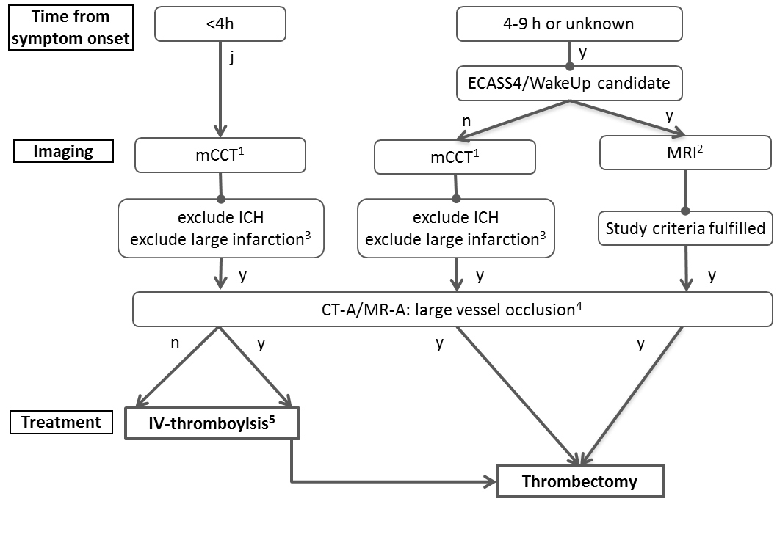
Figure S2: Local SOP valid until April 2017
mCCT = multimodal cranial computed tomography including aortic arch CT-angiography and CT Perfusion, MRI = magnetic resonance imaging, ICH = intracranial hemorrhage, y = yes, n = no
¹ perform in all patients in whom an acute recanalization therapy is considered
² include MR perfusion and aortic arch MR-angiography
³ ASPECTS > 5, infarct core > 100ml
⁴ internal carotid artery, M1, dominant M2
⁵ if there are no contraindications

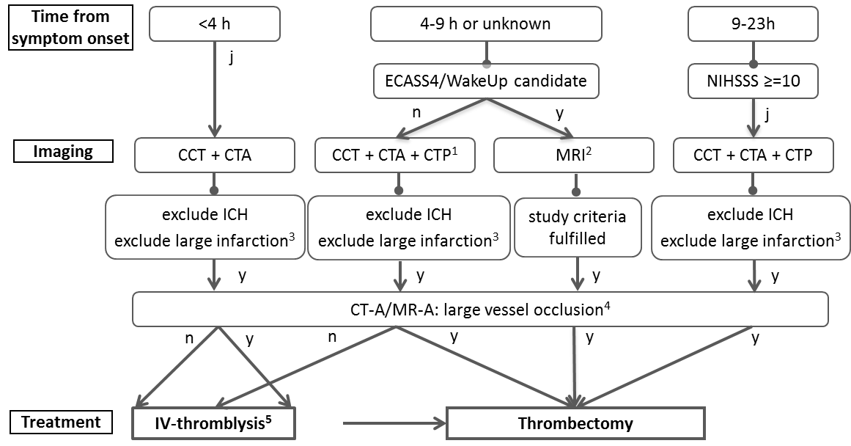

Figure S2: Local SOP in valid from May 2017
CCT = cranial computed tomography, CTA = CT-angiography, CTP = CT Perfusion, MRI = magnetic resonance imaging, ICH = intracranial hemorrhage, y = yes, n = no
¹ especially when symptom onset is unclear
² include MR perfusion and aortic arch MR-angiography
³ ASPECTS > 5, infarct core > 100ml
⁴ internal carotid artery, M1, dominant M2
⁵ if there are no contraindications

Additional analyses for patients not meeting the “HERMESlike” inclusion criteria
Overall, in patients within the given time frame the primary endpoint (mRS 0-2 after 90 days) was reached in 33.5% (252 patients), mortality was 22.5% (169) and sICH occurred in 4.5% (34). Two hundred thirty-eight patients (31.6%) were treated after 6h from last seen well and but the primary endpoint was not different to those treated earlier (33.2% vs. 33.7%, p=0.93).
In patients that did not meet the HERMESlike inclusion criteria (n=362), we performed additional analyses (table S1). In general, these patients were sicker than the HERMESlike patients because of higher frequencies of risk factors, higher premorbid disability and lower ASPECTS at baseline. Despite the fact that patients in the longer time window had significantly lower ASPECTS and lower recanalization rates (table S1), we still did not find a treatment modifying effect of treatment time, i.e. rates of good (mRS 0-2) and favorable (mRS 0-3) and well as death after three months and sICH were not statistically different and very similar in both groups (table S1).

Parameters |  | LSW < 6h  n=231 | LSW > 6h  n=131 | p-value
Clinical baseline data | Age in years, median (min-max) | 78 (46-96) | 74 (46-91) | 0.22#
 | Male Sex (%) | 139 (60.2) | 76 (58) | 0.74*
 | Unwitnessed/Wake Up onset (%) | 0 (0) | 98 (74.8) | <0.001*
 | NIHSS, median (min-max) | 16 (0-38) | 17 (5-25) | 0.09#
 | Premorbid mRS, median (min-max) | 2 (0-5) | 2 (0-4) | 0.012*
Risk Factors | High blood pressure (%) | 193 (83.5) | 100 (76.3) | 0.1*
 | Diabetes (%) | 55 (23.8) | 26 (19.8) | 0.43*
 | High Cholesterol (%) | 87 (37.7) | 45 (34.4) | 0.57*
 | Current smoking (%) | 19 (8.2) | 17 (13) | 0.15*
 | Known atrial fibrillation (%) | 94 (40.7) | 50 (38.2) | 0.65*
 | Newly diagnosed atrial fibrillation (%) | 37 (16) | 18 (13.7)
 | Previous stroke (%) | 71 (30.7) | 26 (19.8) | 0.28*
 | Coronary heart disease (%) | 72 (31.2) | 33 (25.2) | 0.026*
Site of occlusion | Proximal CA (%) | 10 (4.3) | 6 (4.6) | 0.27*
 | Tandem (%) | 21 (9.1) | 22 (16.8)
 | Distal CA (%) | 42 (18.2) | 20 (15.3)
 | M1 (%) | 113 (48.9) | 56 (42.7)
 | M2 (%) | 45 (19.5) | 27 (20.6)
Brain imaging | MRI (%) | 23 (10) | 44 (33.6) | <0.001*
 | CTP (%) | 114 (49.4) | 57 (43.5) | 0.33*
 | ASPECTS, median (min-max) | 9 (1-10) | 8 (3-10) | 0.002#
Procedural data | i.v. thrombolysis (%) | 143 (61.9) | 28 (21.4) | <0.001*
 | LSW to treatment time ( min) | 162+/-53 | 559+/-169 | <0.001$
 | Door to vessel time (DTV, min) | 91+/-45 | 116+/-114 | <0.001$
 | Recanalization (%) | 189 (81.8) | 91 (69.5) | <0.01*
Outcome after 3 months | mRS 0-2 (%) | 46 (19.9) | 31 (23.7) | 0.42*
 | mRS 0-3 (%) | 79 (34.2) | 39 (29.8) | 0.42*
 | mRS 6 (%) | 70 (30.3) | 41 (31.3) | 0.91*
 | sICH (%) | 8 (3.5) | 3 (2.3) | 0.75*

Table S1: Patient characteristics of the patients that did not meet the HERMESlike criteria: NIHSS = National Institute of Health Stroke Scale, mRS = modified Rankin Scale, CA = carotid artery, M1/M2= M2 segment of the middle cerebral artery, MRI = Magnetic Resonance Imaging, CTP = CT Perfusion, ASPECTS = Alberta Stroke Program Early CT Score, LSW = Last seen well, sICH= symptomatic Intracerebral Hemorrhage.* Chi-Square/Fisher-test, # Mann-Whitney-test, $ T-Test

