Online Only Supplemental Material

Title: Onset to Reperfusion Time as a Determinant of Outcomes across a Wide Range of ASPECTS in Endovascular Thrombectomy:
Pooled Analysis of the SWIFT, SWIFT PRIME, and STAR Studies

Supplemental Figures 1 and 2.
Supplemental Tables 1 and 2.

Online Only Supplemental Figure 1. Estimated probabilities of a good outcome (mRS 0-2) at 90 days by workflows according to the baseline ASPECTS categories (ASPECTS 9-10 and 7-8).
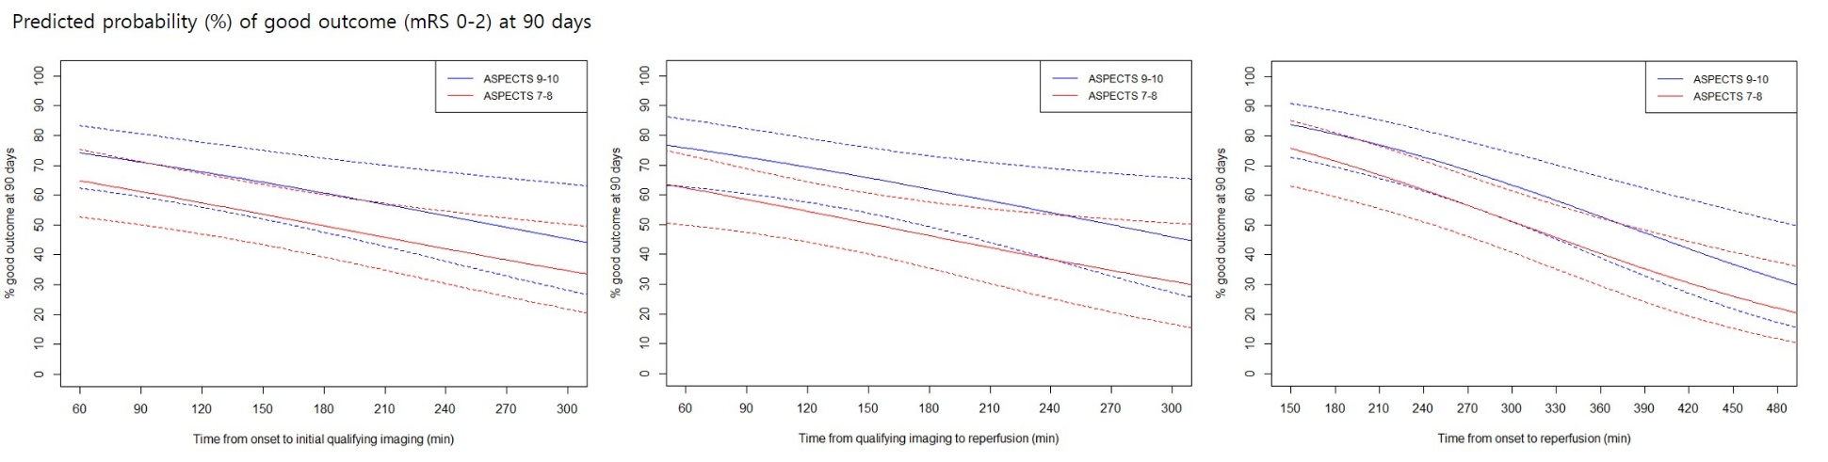

Online Only Supplemental Figure 2. Estimated probabilities of an excellent outcome (mRS 0-1) at 90 days by workflows according to the baseline ASPECTS categories (ASPECTS 9-10 and 7-8).
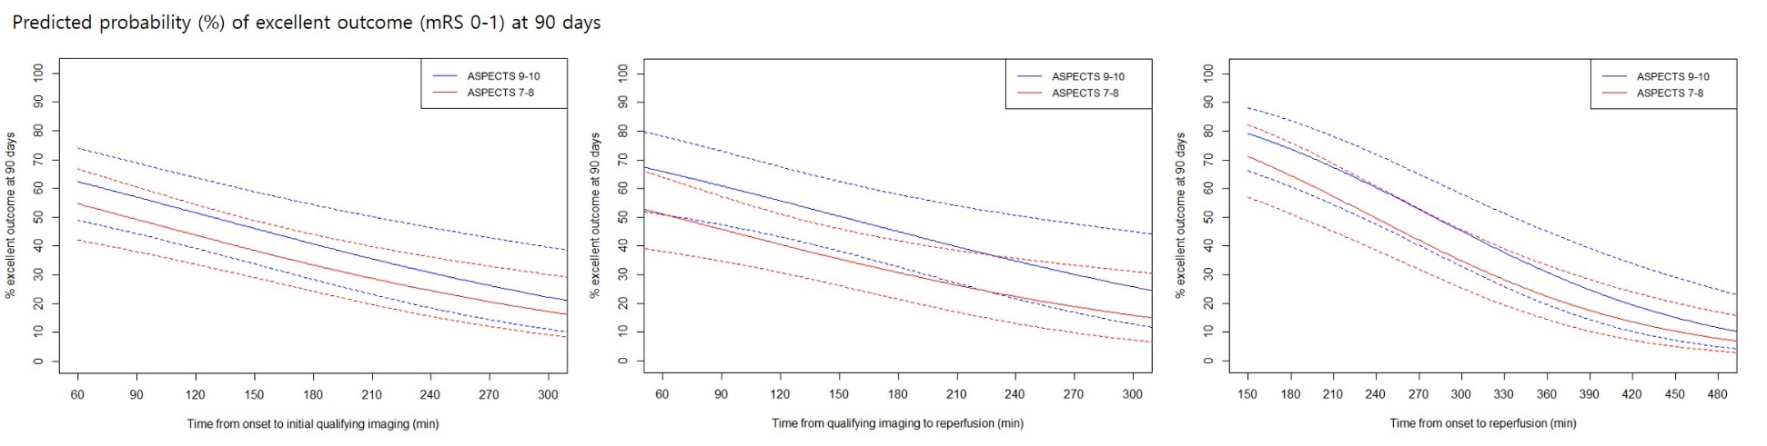

Supplemental Table 1. Characteristics according to baseline ASPECTS categories of patients without substantial reperfusion (mTICI 0-2a) after endovascular therapy.

Characteristic | ASPECTS 9-10 | ASPECTS 7-8 | ASPECTS ≤ 6 | P1 | P2
N | 20 | 23 | 10
Age, mean± SD (years) | 67.7 ± 12.8 | 70.3 ± 10.4 | 57.3 ± 13.7 | 0.47 | 0.10
Male | 45.0% (9/20) | 56.5% (13/23) | 40.0% (4/10) | 0.55 | 0.62
Initial NIHSS, median (IQR) | 14.5 (8, 21) | 16.0 (8, 23) | 18.0 (14, 25) | 0.36 | 0.03
IV-alteplase, % (n/N) | 65.0% (13/20) | 60.9% (14/23) | 70.0% (7/10) | 1.00 | 0.88
Pre-stroke mRS>1, % (n/N) | 11.8% (2/17) | 10.0% (2/20) | 0.0% (0/8) | 1.00 | 0.61
Medical history, % (n/N)
Atrial fibrillation | 35.0% (7/20) | 34.8% (8/23) | 20.0% (2/10) | 1.00 | 0.66
Hypertension | 75.0% (15/20) | 73.9% (17/23) | 30.0% (3/10) | 1.00 | 0.03
CAD/myocardial disease | 5.0% (1/20) | 8.7% (2/23) | 0.0% (0/10) | 1.00 | 0.60
Diabetes mellitus | 15.0% (3/20) | 13.0% (3/23) | 20.0% (2/10) | 1.00 | 0.88
Hyperlipidemia | 55.0% (11/20) | 43.5% (10/23) | 30.0% (3/10) | 0.55 | 0.42
Peripheral artery disease | 0.0% (0/20) | 0.0% (0/23) | 0.0% (0/10) | 1.00 | 1.00
Smoking | 15.0% (3/20) | 13.6% (3/22) | 40.0% (4/10) | 1.00 | 0.18
Prior stroke/TIA | 25.0% (5/20) | 17.4% (4/23) | 10.0% (1/10) | 0.71 | 0.60
Glucose at presentation, mean±SD | 136.2 ± 54.6 | 105.9 ± 40.2 | 121.7 ± 25.9 | 0.046 | 0.22
Occlusion location, % (n/N) |  |  |  | 0.65 | 0.44
ICA | 16.7% (3/18) | 22.7% (5/22) | 10.0% (1/10)
M1 MCA | 72.2% (13/18) | 68.2% (15/22) | 80.0% (8/10)
M2 MCA | 11.1% (2/18) | 9.1% (2/22) | 0.0% (0/10)
M3 MCA | 0.0% (0/18) | 0.0% (0/22) | 10.0% (1/10)
Time from onset to (min)
hospital arrival, median (IQR) | 170 (33, 387) | 110 (30, 375) | 300 (37, 585) | 0.16 | 0.19
qualifying imaging | 85.5 (41, 367) | 120 (38, 334) | 186.5 (22, 613) | 0.72 | 0.02
groin puncture | 266.5 (148, 435) | 220 (124, 515) | 344.5 (185, 714) | 0.29 | 0.18
Time from hospital arrival to (min)
qualifying imaging | 26.5 (13, 73) | 35 (3, 158) | 24 (5, 151) | 0.57 | 0.78
groin puncture | 86.5 (32, 265) | 105 (21, 288) | 69.5 (29, 220) | 0.408 | 0.86
Time from qualifying imaging to (min)
groin puncture | 143 (63, 266) | 88 (41, 274) | 79 (33, 358) | 0.07 | 0.17
* Negative values in parentheses for the time from hospital arrival to qualifying imaging: initial imaging was often performed prior to arrival at the endovascular care center.
P₁; comparison of ASPECTSs 9-10 vs 7-8, P₂; comparison among the 3 groups.

Supplemental Table 2. Unadjusted rates of outcomes according to the baseline ASPECTS categories.
Characteristic | ASPECTS 9-10 | ASPECTS 7-8 | ASPECTS ≤ 6 | P1 | P2
N | 20 | 23 | 10
mRS 0-2 at 90 days | 33.3% (6/18) | 30.4% (7/23) | 40.0% (4/10) | 1.00 | 0.87
mRS 0-1 at 90 days | 27.8% (5/18) | 21.7% (5/23) | 20.0% (2/10) | 0.72 | 0.87
sICH | 0.0% (0/20) | 0.0% (0/23) | 0.0% (0/10) | 1.00 | 1.00
Mortality within 90 days | 5.0% (1/20) | 13.0% (3/23) | 10.0% (1/10) | 0.61 | 0.67
In-hospital mortality | 0.0% (0/20) | 4.3% (1/23) | 0.0% (0/10) | 1.00 | 0.51
P1; comparison of ASPECTSs 9-10 vs 7-8, P₂; comparison among the 3 groups.

